U
C
R
A

Unified Carrier Registration Agreement

Training Guide

August 2008

Table of Contents

Who is subject to UCRA? (Slide No. 4) 2
What is required for Registrants under UCR? (Slide 12) 4
How is the base state determined? 5
Why is it important to determine the carrier’s proper base state? (Slide 18) 6
How can you change your base state? (Slide 19) 6
What is required annually? (Slide 20) 6
Parts of the application form (Slide 21) 6
How to complete the application form (Slides 22 through 30) 6
Where are the fees and information filed? (Slide 31) 7
Are there additional fees charged for using the national web based system? (Slide 32) 8
Is the UCR registrant required to carry a credential on the vehicle? (Slide 33) 8
Submission of a State Plan (Slide 36) 9
Forms Processing by State Agency Personnel (Slide No. 37) 9
Collection of fees (Slide 38) 11
Transmission of data and fees (Slide 39) 11
State Recordkeeping (Slide 40) 11
How does UCR affect intrastate regulation? (Slides 41 & 42) 12
Flow Chart of UCR Functionality 13
How do I determine if a carrier is in compliance with UCR? (Slides 44 - 48) 14
What if the carrier has added trucks this year and those vehicles weren’t included in the UCR fleet count? (Slide 50) 17
Does the “lessee” or the “lessor” pay for the UCR? (Slide 51) 17
How often is compliance data updated? (Slide 52) 17
How does UCR affect companies with interstate and intrastate operations? (Slide 53) 18
Examples of roadside enforcement activity and possible enforcement action (Slide 54 through 61) 18
UCR Board Question and Answer Document 22

Disclaimer: This training guide was prepared in sections in order to segment this training program dependent upon the audience needing to be reached. This guide is not all encompassing and is intended to reiterate what is stated in the UCR Agreement. The information provided here is based on the informal interpretation of the Unified Carrier Registration Act of 2005 (“UCR Act”) and is subject to further interpretation by the UCR Board.

Chapter 1 – Industry Perspective

Who is subject to UCRA? (Slide No. 4)

Any motor carrier that operates in interstate or international commerce is subject to the UCR Agreement. In addition, many businesses that were not subject to the old Single State Registration System – private carriers, exempt carriers, regulated carriers that did not travel into SSRS states, brokers, freight forwarders and leasing companies are also subject to the UCR Agreement. Carriers based in Canada and Mexico that operate in the United States are subject to the UCR Agreement.

Carriers previously exempted under Title 49, Subtitle IV, Part B, Chapter 135 or other exemption actions by the former Interstate Commerce Commission were included in the definition of motor carrier under the UCR Act. This includes inter-corporate hauling, operating within commercial zones, transportation to and from a farm, transportation of passengers incidental to air, tow truck service (including emergency towing) and other motor carrier exemptions under that section of the law. Keep in mind, the definition of motor carrier still needs to be applied to those exemptions.

Definition of a Motor Carrier (Slide No. 5 & 6)

A motor carrier means a person providing commercial motor vehicle transportation for compensation. The definition of commercial motor vehicle references Title 49, Subtitle VI, Part B, Chapter 311, Subchapter III, Section 31132. Here, “commercial motor vehicle” means a self-propelled or towed vehicle used on the highways in interstate commerce to transport passengers or property, if the vehicle—
(A) Has a gross vehicle weight rating or gross vehicle weight of at least 10,001 pounds, whichever is greater;
(B) Is designed or used to transport more than 8 passengers (including the driver) for compensation;
(C) Is designed or used to transport more than 15 passengers, including the driver, and is not used to transport passengers for compensation; or
(D) Is used in transporting material found by the Secretary of Transportation to be hazardous under section 5103 of this title and transported in a quantity requiring placarding under regulations prescribed by the Secretary under section 5103.

The change to the definition adds some confusion with the verbiage in subpart (C). It is important here to remember that a motor carrier using a vehicle to transport passengers or property must do so for compensation, use commercial motor vehicles in interstate commerce to be a motor carrier. This would include vehicles that travel only in one state but transporting property or passengers in interstate commerce.

Definition of a Motor Private Carrier (Slide 7)

As defined un Title 49, Subtitle IV, Part B, Chapter 131, Section 13102, the term “motor private carrier” means a person, other than a motor carrier, transporting property by motor vehicle when—
(A) the transportation is as provided between a place in—
- A State and a place in another State;
- A State and another place in the same State through another State;
- The United States and a place in a territory or possession of the United States to the extent the transportation is in the United States;
- The United States and another place in the United States through a foreign country to the extent the transportation is in the United States; or
- The United States and a place in a foreign country to the extent the transportation is in the United States; and
- In a reservation under the exclusive jurisdiction of the United States or on a public highway.
(B) the person is the owner, lessee, or bailee of the property being transported; and
(C) the property is being transported for sale, lease, rent, or bailment or to further a commercial enterprise.

The important points here to remember is that this definition references the transportation of property not passengers, that the transportation must be provided in furtherance of interstate commerce, that the person owner of the property being transportation and that the property is being transported for sale or in furtherance of a commercial enterprise or business. With these points in mind, you can determine that transportation of personal property across state lines not in furtherance of a commercial enterprise is not private carriage (for example: transporting horses to ride on a friends property or transporting 4-H cattle projects for show and not for sale).

The transportation of passengers not for hire does not fall under the UCR agreement for filing.

Definition of a Leasing Company (Slide 8)

The term ‘leasing company’ means a lessor (or owner) that is engaged in the business of leasing or renting for compensation motor vehicles without drivers to a motor carrier, motor private carrier, or freight forwarder.

Specifically under the law, leasing companies file and pay the lowest fee established. When vehicles are leased to a motor carrier under a long-term lease, the motor carrier files the UCR application and counts the number of commercial motor vehicles, not the leasing company.

Definition of a Broker (Slide 9)

A broker is similar to a third party outside sales service that arranges transportation movements between the shipper and the motor carrier for compensation. As a broker, they do not transport any of the movements they arrange. Under the UCR agreement, brokers file and pay the lowest fee established.

Definition of a Freight Forwarder (Slide 10)

A freight forwarder consolidates shipments using various modes of transportation. A freight forwarder is not a motor carrier. Under the UCR agreement, a freight forwarder files and pays the lowest fee established.

Combination Operations (Slide 11)

A single entity (sole proprietorship, partnership or form of corporation) may a motor carrier and a broker or other type of operation. If the entity is a motor carrier or motor private carrier, the single entity would file only as a motor carrier or motor private carrier. That entity would not register again as a broker but only register once.

A person operating two separate legal entities (a motor carrier and also a broker) would be required to register twice under the UCR agreement, once as a motor carrier and again as a broker. For example: ABC Trucking Inc. (interstate motor carrier) and ABC Brokerage Company (interstate broker) are separate registered corporations owned and operated by the same owner. Each would be required to file under the UCR agreement. It is immaterial that the two companies are related, affiliated or owned by the same owner.

What is required for Registrants under UCR? (Slide 12)

The registrants have two requirements under the law to meet and submit to their base state–
  - An annual submission of information; and
  - Payment of fees.

The UCR Board determines the information needed to be submitted to the base state. The UCR Board develops and recommends the fee structure to the Secretary of the US DOT. After notice and opportunity for public comment, the Secretary will set the fees for the next year and any subsequent adjustment to those fees.

How is the base state determined?

Each registrant must select a base state. The registrant may not select the state that host the national web system as its base state unless that state is properly selected using the process described below.
Step 1. (Slide 13)
The first and easiest method to determine the registrant’s base state is if the registrant’s principal place of business is located in a participating state. The registrant must use this state as its base state. The principal place of business is defined as a single location that serves as a motor carrier’s, motor private carrier’s, broker’s, leasing company’s or freight forwarder’s headquarters and where it maintains or can make available its operational records.

If the registrant does not have its principal place of business in a participating state, go to Step 2.

Step 2. (Slide 14)
If the registrant has an office(s) or operating facility(ies) located in a participating state, the registrant may select that state as it base state. If the registrant does not have an office or operating facility in any state or the office or operating facility is not located in a participating state, go to step 3.

Step 3. (Slides 15 & 16 )
The registrant has two options. The company may select a participating state if it is geographically close to the carrier’s principal place of business; OR select a participating state within the carrier’s FMCSA region.

FMCSA Region | State |  | Canada/Mexico
Eastern | CT,DE,MA.ME,NH,NY,PA,RI,VA,WV |  | ON,NB,NL,NS,PE,QC
Midwestern | IA,IL,IN,KS,MI,MN,MO,NE,OH,WI |  | ON,MB
Southern | AL,AR,GA,KY,LA,MS,NC,OK,SC,TN,TX |  | Mexico
Western | AK,CA,CO,ID,MT,ND,NM,SD,UT,WA | AB,MB,SK,BC

Why is it important to determine the carrier’s proper base state? (Slide 17)

The fees that are collected are kept by the base state until that state reaches the amount of fees it is entitled to. If the carriers are not filing in the proper base state, that state will have a delay in getting the amount of fees due.

How can you change your base state? (Slide 18)

The registrant may change its selection of a base state when the registrant changes its principal place of business. The registrant shall change it base state if the state in which the principal place of business is located becomes a participating state. If the registrant establishes a new office or operating facility in a participating state, it may at the next registration period select that state as its base state. The registrant should notify the old base state of any change to the designation of a base state.

What is required annually? (Slide 19)

The registrant is required annually to do only two things:
File and annual application; and
- Pay the appropriate fees.

Parts of the application form (Slide 20)

Section 1 – General Information identifying the registrant
Section 2 – Classification of the registrant
Section 3 - Fees Due - Brokers, Freight Forwarders and Leasing Companies
Section 4 - Number of motor vehicle - Motor Carriers and Motor Private Carriers
Section 5 - Fee Table
Section 6 – Fees Due
Section 7 – Certification

How to complete the application form (Slides 21 through 29)

Some states may pre-fill the information that the registrant submitted on its last MCS 150 form on file with FMCSA. If so, this information should be reviewed and any corrections needed should be done by filing a new MCS 150 form.

Section 1. Fill in the general information on the registrant.
Section 2. Classification – Check all that apply.
Section 3. If classification in Section 2 indicates only a broker, freight forwarder or leasing company, pay $39 and go to Section 7, sign application and mail.
Section 4. There is a misconception particularly in this section on what number of commercial motor vehicles are to be reported. This form will not reflect what is the current number of commercial motor vehicle the registrant owns or operates. There are only two ways to determine the number of motor vehicles to be shown in this section:
–The number reported on the last MCS-150 (this number may be as old as almost two years since the requirement is to file a new MCS-150 form every 24 months); OR
–Total number owned or operated for the 12-month period ending June 30 of the year immediately prior to registration. The state has the right to audit the numbers reported.

Any changes in your current operation will be reflected on a future registration. It is important to note here that the definition of a commercial motor vehicle for including on the MCS-150 form is:
Self-propelled or towed vehicle used on the highways in commerce principally to transport passengers or cargo, if the vehicle:
(1) Has a gross vehicle weight rating or gross vehicle
weight of at least 10,001 pounds, whichever is greater;
(2) Is designed to transport more than 10 passengers
including the driver; or
(3) Is used in transporting material found by the Secretary of Transportation to be hazardous under 49 U.S.C. Section 5103 and transported in a quantity requiring placarding under regulations prescribed by the Secretary.

There are limited ways to adjust the number of vehicles reported after you have initially selected the number to report in this section. These are:
–Option 1 – Deleting Vehicles. You may delete only trucks or trailers used only in intrastate commerce.
–Option 2 – Adding Vehicles. You may add vehicles not shown on the MCS 150 that are commercial motor vehicles and used only in intrastate commerce and/or other self-propelled motor vehicles.

No other adjustments may be made to this vehicle count. Vehicles wreck and no longer in the fleet or vehicles added after the filing of the last MCS-150 are not included or deleted from this form. If large changes have occurred to your fleet size, you may want to file a new MCS-150, which will allow you to use those numbers on this reporting period.

Section 5. This section of the application form indicates the level of fees in the various vehicle categories. Each year, these fees will be reviewed by the UCR Board to make sure that they are sufficient to cover state entitlements.
Section 6. Use the total number of vehicles reported in Section 4, locate the fee amount for the vehicle category and pay the amount due.
Section 7. Your signature on this form indicates that the information is true and correct. Any intentional reporting of false information may subject the company to state enforcement action.

Where are the fees and information filed? (Slide 30)

Along with the application form is information supplied for mailing application forms or state and national web based systems that may be used for filing under the UCR agreement. Information is also supplied as to the types of payment accepted.

Are there additional fees charged for using the national web based system? (Slide 31

There is a 3.00 transaction fee for use of the system, a $1.00 fee for selection of payment using an electronic check and a credit card percentage charge dependent on the dollar amount if a credit card is used.

Is the UCR registrant required to carry a credential on the vehicle? (Slide 32)

No. A copy of the payment receipt may be carried in the vehicle(s) if desired.

Chapter 2 - State Perspective

Submission of a State Plan (Slide 35)

Any state is eligible to participate in the UCR agreement only if the state submits to the Secretary of the US DOT a state plan prior to August 10, 2008. The state must identify the state agency that has or will have the legal authority, resources and personnel necessary to administer the agreement and demonstrate that the revenue derived by the state shall be used for motor carrier safety programs.

If a state fails to submit a state plan by that date or withdrawals form the plan, it may not thereafter participate in the UCR agreement.

Forms Processing by State Agency Personnel (Slide No. 36)

An entity registering in the UCRA has two options:
- Apply online at http://www.ucr.in.gov/ and follow the directions given; or
- Apply directly with the appropriate base-state agency using the registration form approved by the UCR Plan Board of Directors.

Additionally, entities registering in the states of Alabama, Iowa, Illinois, Maine, North Dakota, and Virginia may opt to use online registration systems developed by those states for use by registrants based in those respective states.

These UCRA registration form processing guidelines apply whether the data from the registration is being entered into the Indiana Department of Revenue (INDOR) online system or into an individual state’s database. In both situations, the data will eventually be uploaded into the federal Safety and Fitness Electronic Records System (SAFER) at http://safer.fmcsa.dot.gov for enforcement purposes throughout the United States.

For state agency personnel entering this data, accuracy is imperative so that the fees collected are credited to the correct registrant and to the correct base-state.

Step 1.

Compare the registrant’s information in Sections 1 and 2 of the UCRA registration form with the information found in SAFER. If all the information is correct, proceed to Step 3.

Step 2.

Certain discrepancies may require corrections or updating by the registrant before the registration can be completed. For instance, a registrant listed in SAFER as an intrastate only carrier will not be allowed to complete the UCRA registration until SAFER is updated to indicate the registrant is an interstate carrier.

Other discrepancies may be such that the registration can be completed but the registrant may be advised to make the corrections as soon as possible. Although every scenario cannot be covered here, the following language is provided to assist states in preparing the advisements.

NAME DIFFERENT
Please note the name on the UCRA receipt does not exactly match the name you placed on your UCRA registration form, however, since the legal entity appears to be the same, your UCRA registration form was processed.

NUMBER OF VEHICLES DIFFERENT
Please note the number of vehicles (power units and/or trailers) you reported on your UCR registration form did not exactly match the number of vehicles shown on your last MCS-150 (Motor Carrier Identification Report), however, since the UCRA fee tier was the same, your UCRA registration form was processed.

NEEDS FEDERAL AUTHORITY
While processing your UCRA registration form, we reviewed your USDOT number information over the internet at http://safer.fmcsa.dot.gov, which shows you are a for-hire interstate motor carrier required to obtain motor carrier authority from FMCSA (based upon the cargo carried). To obtain motor carrier authority from FMCSA, go to http://www.fmcsa.dot.gov/registration-licensing/registration-licensing.htm, or call 800-832-5660 to have forms mailed to you.

ADDITIONAL UPDATE INFORMATION
You can update your USDOT number snapshot over the internet at http://safer.fmcsa.dot.gov by filing a MCS-150 (Motor Carrier Identification Report). To update online you will need a Personal Identification Number (PIN), which you can also apply for online at http://www.fmcsa.dot.gov/registration-licensing/online-registration/onlineregdescription.htm. You may also update your USDOT record by filing a MCS-150 by mail to FMCSA, MCMIS Team, 1200 New Jersey Avenue SE, Washington, DC 20590. Please put “update” on the MCS-150 form and make all necessary changes. To have a MCS-150 form mailed to you, call the FMCSA at 800-832-5600.

Step 3.

Ensure that the UCRA fees submitted are correct based on the total number of vehicles reported on Line 3, Section 4, of the UCRA registration form. Acceptable forms of payment will be according to the base-state’s payment policy.

Step 4.

Provide the registrant with a receipt for the payment of the UCRA fees. It is recommended that you advise the registrant that a copy of the receipt is not required to be carried in the vehicle(s) for which payment was made, but may be carried at the registrant’s option.

Step 5.

Enter the data from the UCRA registration form into the UCR National system hosted by the state of Indiana using the password protected state agency portal or utilize the base state system ensuring the required data elements are uploaded daily to SAFER.

Do not enter the data using the http://www.ucr.in.gov/ portal as that is for use by the registrant only. Your agency may want to make a computer with Internet access available to walk-in registrants in order to give them the option of registering directly into the UCR National system.

Collection of fees (Slide 37)

The base state can only collect fees from registrants who can lawfully select that state as their base state. The base state will retain all of the fees collected from its registrants until the state reaches is state entitlement as certified to the UCR Board. The base state will monthly calculate the amount of fees collected to ensure that it is not retaining more than it is entitled.

If the base state collects fees from a registrant and that state is not its lawful base state, the state that collected the fees may correct the error, transmit the fees to the proper state and deduct that amount from their entitlement.

The base state shall not issue a refund of UCR fees to a registrant that changes or ceases its business operation after the beginning of the registration year. The base state may issue a refund of UCR fees to a registrant that ceases its operations before the beginning of the registration year for which fees were paid. A written request shall be required before the refund can be issued. Any refunds issued by the Base State shall be deducted from the amount of UCR fees that the State shall be credited with collection for the registration year.

Transmission of data and fees (Slide 38)

The base state is required to transmit data to the UCR board within 30 days of the close of a month the total amount of funds collected and the amount of excess funds collected if any. The base state is also required to transmit registrant compliance data to FMCSA to ensure that state enforcement staff may enforce the UCR filing requirements.

If a state collects more than its entitlement, the state will within 30 days from the close of the month, transmit excess funds to the UCR Board Depository. The UCR Board will distribute the fees out of the depository to those states on a pro-rata basis who have not received all their entitlement.

State Recordkeeping (Slide 39)

The Base State shall maintain copies of paper records submitted by registrants. The records shall contain, but not be limited to, UCR forms, correspondence and payments. The required records shall be maintained on paper, microfilm, microfiche or any other computerized or condensed record storage system, which meets the legal requirements of the Base Stat. Required records shall be maintained for a minimum of three years.

How does UCR affect intrastate regulation? (Slides 40 & 41)

The UCR Act does not affect a State’s ability to:
- Regulate intrastate only carriers;
- Require and interstate carrier to apply for intrastate authority, file and maintain proof of insurance, charge an application fee or require tariffs to be filed (as applicable); nor
- Require an annual renewal and credentials for motor carriers transporting non-charter passenger service, waste or recyclable materials or household goods.

The UCR Act does affect a State’s ability to impose on an interstate motor carrier who also holds intrastate authority a renewal application and the requirement to purchase and display an intrastate credential.

Flow Chart of UCR Functionality

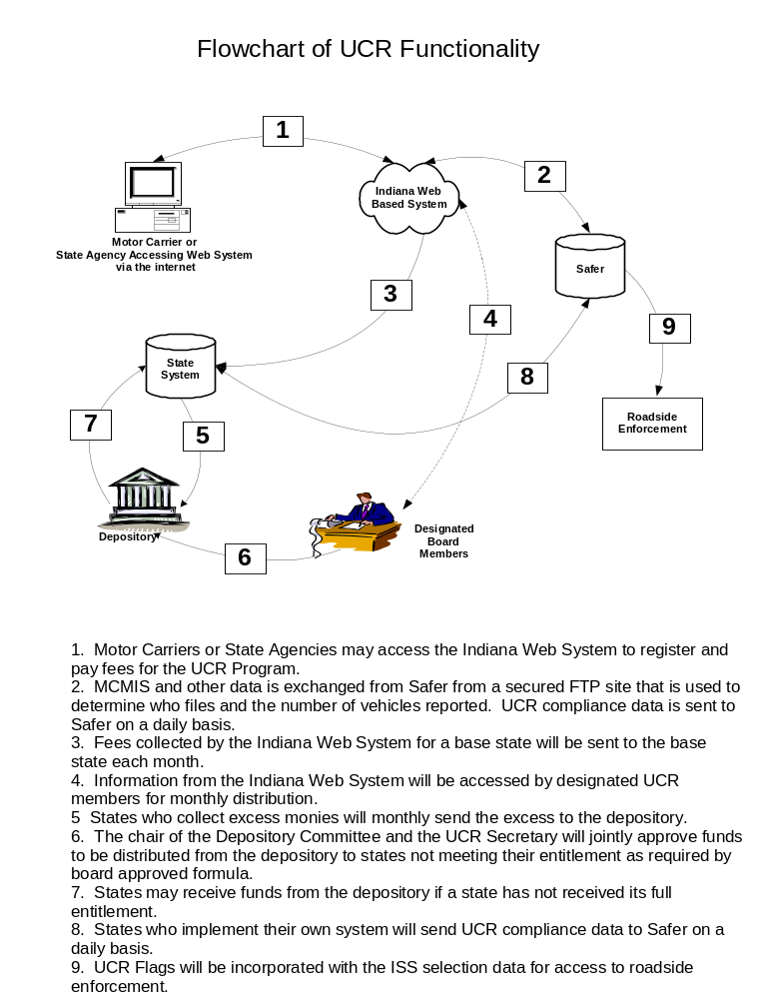
Chapter 3 – Enforcement Perspective

How do I determine if a carrier is in compliance with UCR? (Slides 43 - 47)

The state and national systems will have access to information in FMCSA’s MCMIS system to register or renew under the UCR agreement. Information from these systems will be uploaded to FMCSA to be stored and disseminated to the public and field enforcement staff.

To verify compliance, you may:
- Access the Internet at www.safersys.org under FMCSA Searches, Unified Carrier Registraion (UCR);
- Access ISS (Inspection Selection System);
- Check your CVIEW (if you have one available and UCR compliance data is included); or
- Check with the base state of the carrier.

While a carrier may be issued a “receipt” based upon the UCR fee paid, there is no credential issued or any requirement for proof of payment to be carried in the vehicle.

- To check for UCR compliance on WWW.SAFERSYS.ORG, Click on “Unified Carrier Registration (UCR).

Click the appropriate search selection:
- USDOT number
- MC/MX number
- FF number

Key in the appropriate number. Click the “Search” Button.

- A screen result of a compliant carrier returns the following information:

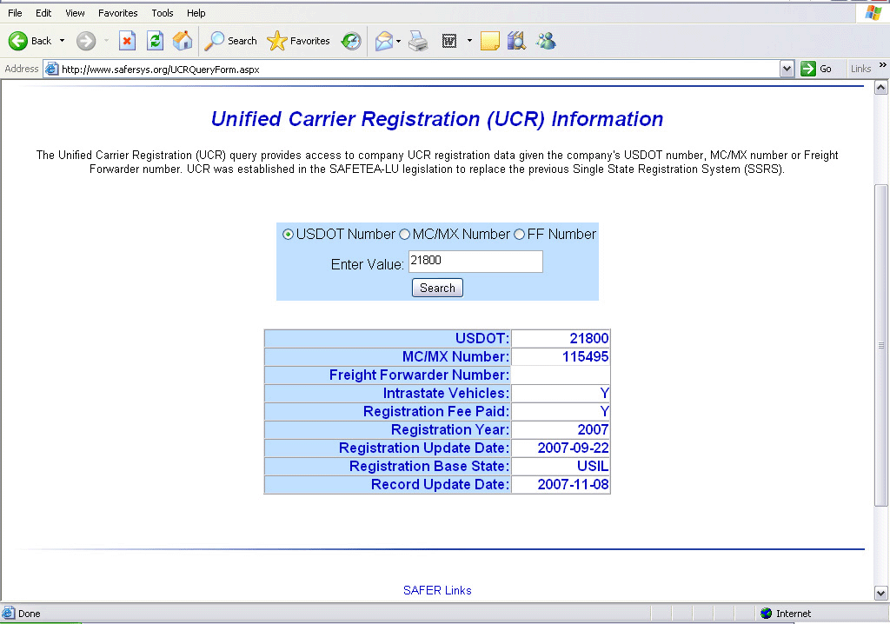

- Explanation of fields displayed for a compliant carrier:
  - USDOT: - The USDOT number of the UCR registrant.
  - MX/MX NUMBER: - The MC/MX number of the UCR registrant.
  - FREIGHT FORWARDER NUMBER: The Freight Forwarder Number of the UCR registrant.
  - INTRASTATE VEHICLES: Indicates whether the UCR registrant “excluded” any vehicles – using Section 4, Line 1 (Optional) - on its UCR registration.
Y = Yes - Intrastate vehicles were excluded from UCR fee
N = No - No intrastate vehicles were excluded from UCR fee
  - REGISTRATION FEE PAID: Indicates whether a UCR fee for a UCR registration year has been paid.
Y = Yes
N = No
  - REGISTRATION YEAR: Reflects the most recent UCR registration year for which the UCR registrant paid its UCR fee.
  - REGISTRATION UPDATE DATE: In YYYY-MM-DD format, reflects the date the UCR registrant registered in its most recent UCR registration year (see Registration Year line above).
  - REGISTRATION BASE STATE: Reflects the state (in the United States) that serves as theUCR registrants base state for UCR purposes.
  - RECORD UPDATE DATE: In YYYY-MM-DD format.

- A search result of a non-compliant carrier returns a message “No data found for this query” in blue on the left side of the screen.

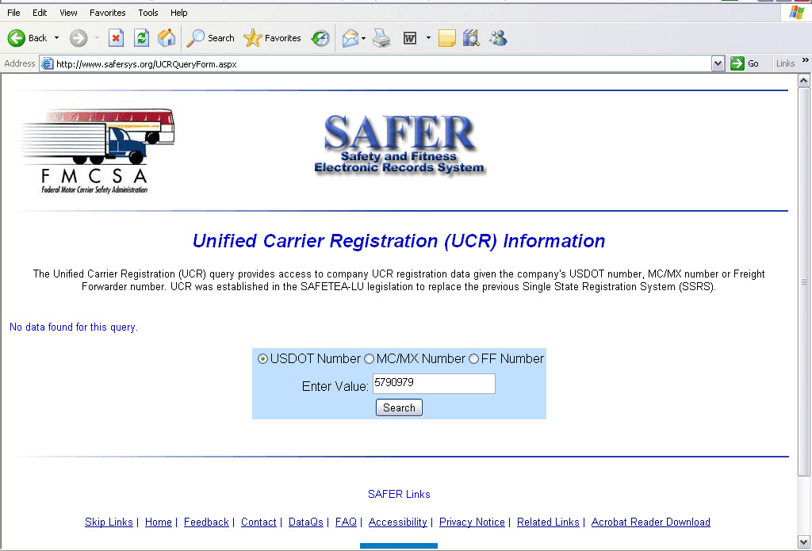

How do I know if the proper UCR fee was paid? (Slide 48)

The information may not be available at the roadside to do so and therefore compliance may only be verified that the registrant has paid a fee under the program.

If information is available or if the enforcement officer sees something that may indicate that proper fees have not been paid, the enforcement office will need to understand how the fees are calculated. Motor carriers first begin by determining if they want to pay based upon the number of commercial motor vehicles reported on their last MCS-150 form (which is the form used to obtain to update their USDOT # information - updates are required every two years) or the total number of commercial motor vehicles owned and operated for the 12-month period ending June 30 of the year immediately prior to the year for which the UCR registration is made. Either way, the carrier reports both owned and leased vehicles (term of lease for more than 30 days).

Vehicles designed to transport 10 or less passengers (including the driver) are not defined as a commercial motor vehicle for purpose of payment of fees under this program. Brokers, Freight forwarders and leasing companies (that don’t operate CMVs) pay the lowest fee tier (0-2) at $39.00. If they also operate as a motor carrier (for-hire or private), they pay a fee commensurate with the number of CMVs operated. A UCR registrant pays only the fee for one category they operate under (the highest fee), even if they qualify to register under more than one category, i.e., a freight forwarder and a for-hire carrier. Motor Carriers that transport regulated commodities for hire (requiring FMCSA authority shown on License & Insurance) but don’t utilize CMVs also pay the lowest fee tier (0-2) at $39.00. A motor carrier can also “include intrastate” or “exclude intrastate” vehicles. Carriers that “exclude” intrastate vehicles are required to purchase and display an intrastate ID (if the vehicle is engaged in regulated intrastate operations). Excluded vehicles should also display an in-state license plate.

What if the carrier has added trucks this year and those vehicles weren’t included in the UCR fleet count? (Slide 49)

There are no “supplemental” applications under UCR. If a carrier adds vehicles to their fleet during a year, they simply report the total number of CMVs operated this year on next year’s UCR application or when the MCS 150 form has been updated. The only way to know if a carrier has “under-reported” their vehicles is through an audit or through regular encounters with a carrier’s transportation operations that span over one registration year.

Does the “lessee” or the “lessor” pay for the UCR? (Slide 50)

The UCR program requires the operating carrier to pay for all vehicles leased over 30 days.

How often is compliance data updated? (Slide 51)

If a check of the UCR compliance information on www.safersys.org does not show the carrier to be in compliance and a violation is written, will the carrier be able to prove that compliance was in place at that time? The data found on the SAFER site may be up to two days old. The information provided by the national system sponsored by the state of Indiana sends updates once a day (at night). The information provided to FMCSA will be updated the next night. There are seven (7) states running their own system (Alabama, Illinois, Iowa, Maine, Montana, North Dakota and Virginia). They are supposed to be uploading to SAFER once a day also. If this situation occurs, the carrier likely registered the day before and the data has not been updated in the federal system.

How does UCR affect companies with interstate and intrastate operations? (Slide 52)

- A company with interstate and intrastate operations must file under the UCR agreement. Failure to do so subjects the company to state enforcement action for failure to file and pay proper fees under the UCR program. A state may not subject the company for violations of failure to comply with intrastate renewal requirements except for carriers transporting non-charter passengers, waste or recyclable materials or household goods.

If an interstate carrier with intrastate authority drops their interstate operations from SAFER, they may be required to renew their intrastate authority with that state.

A carrier has an active USDOT # as is an interstate private carrier and the carrier obtained an intrastate authority two years ago (which has not been renewed). The carrier is stopped, engaged in intrastate operations but has no UCR. Is the carrier in violation of state intrastate requirements? If the carrier is in good status in the state where the intrastate authority is held, the carrier doesn’t need to have complied with the UCR agreement to qualify for the “intrastate renewal preemption” or the “intrastate credential preemption”, they just have to be an interstate carrier. The carrier may be in violation for not registering under the UCR program (depending upon the individual state’s enforcement policies).

- Does the “don’t have to renew the intrastate license” or the “don’t have to carry the intrastate license/credential” preemption for interstate carriers also apply to a household goods certificate, recyclable materials, or hazardous waste credential? No, these credentials must still be obtained, renewed and carried in each applicable vehicle if the state requires them.

Examples of roadside enforcement activity and possible enforcement action (Slide 53 through 60)

Example 1.

Carrier: Total Trucks = 110
100 UCR registered trucks
10 exclusively intrastate not UCR registered

Description of truck stopped for inspection:
Apportioned plate over 26,000 lbs
No IFTA
Bill of lading showing interstate move
Private carriage
No federal authority
No intrastate authority

Possible enforcement action:

No IFTA

Example 2.

Carrier: Total Trucks = 110
100 trucks not UCR registered
10 exclusively intrastate not UCR registered

Description of truck stopped for inspection:
Apportioned plate over 26,000 lbs
IFTA
Bill of lading showing interstate & intrastate moves
Private carriage
No federal authority
No intrastate authority

Possible enforcement action:

No UCR registration

Example 3.

Carrier: Total Trucks = 10
No UCR registered trucks
10 exclusively intrastate not UCR registered

Description of truck stopped for inspection:
Straight tag
No IFTA
Bill of lading showing air freight move
For-hire carriage
No federal authority
No intrastate authority

Possible enforcement action:

No UCR registration

Example 4.

Carrier: Total Trucks = 1
No UCR registered trucks
1 exclusively intrastate not UCR registered

Description of truck stopped for inspection:
Farm tag
No IFTA
Farmer moving his grain to local barge terminal where the movement is known to be interstate
Private carriage
No federal authority
No intrastate authority

Possible enforcement action:

No UCR registration

Example 5.

Carrier: Total Trucks = 110
No UCR registered trucks
10 exclusively intrastate not UCR registered

Description of truck stopped for inspection:
Apportioned plate over 26,000 lbs
No IFTA
Bill of lading showing interstate move
Private carriage
No federal authority
No intrastate authority

Possible enforcement action:

No IFTA
No UCR registration

Example 6.

Carrier: Total Trucks = 110
No UCR registered trucks
10 exclusively intrastate not UCR registered

Description of truck stopped for inspection:
Apportioned plate over 26,000 lbs
IFTA
Bill of lading showing interstate & intrastate moves
For-hire carriage
No federal authority
No intrastate authority

Possible enforcement action:

No federal authority
No for-hire intrastate authority
No UCR registration

Example 7.

Carrier: Total Trucks = 110
100 UCR registered trucks
10 exclusively intrastate

Description of truck stopped for inspection:
Apportioned plate over 26,000 lbs
IFTA
Bill of lading shows intrastate move
For-hire carriage
No federal authority
Has intrastate authority

Possible enforcement action:

None

Example 8.

Carrier: Total Trucks = 110
100 UCR registered trucks
10 exclusively intrastate

Description of truck stopped for inspection:
Out-of-state farm plate
IFTA
Interstate move
Farmer moving for-hire
No federal authority
No intrastate authority

Possible enforcement action:

No UCR registration
No federal authority

Questions and Answers – Chapter 4

UCR Board Question and Answer Document

The UCR Board maintains a Q & A document that can be used to help with specific questions relating to this program. This document can be found at http://www.naruc.org/NCSTS/index.cfm?pg=updates. Any questions may be brought to the board or the Procedures Committee.

